1. Abstract

In every institute or in a city there are libraries. A lot of software’s are being made in the past to manage the library system so that easy and proper functioning of the library can be there. This project aims at building such a project by implementing some of the functionalities that has been present in the older software’s using the content and the knowledge.

Giving a brief overview of the project is that this will be a core java project. The information regarding the books and members of the library is stored in the database. Very basic and user friendly screens will be there for a good user experience and for the most part it will be implementing some easy and necessary features of the library management system.

The proposed system will have following functionalities :
- Very friendly user interface.
- Easy to issue and return books.
- Easy to search books.
- Adding and deleting of members will be easy.
- Adding and deleting of books will be easy.
- Can view all the members of the library
- View all the books in the library

For accomplishing these functionalities very easy screens will be provided. Complex features of the general library management system will not be implemented but this system will be very useful for the staff in the library rather than the students. This will be small software implementing some easy features of the library management system in practice.

2. Introduction

The project titled Library Management System is Library management software for monitoring and controlling the transactions in a library .The project “Library Management System” is developed in java, which mainly focuses on basic operations in a library like adding new member, new books, and updating quantity of books , searching books deleting books , issuing books . Some of these facilities required the admin login so that the members of the library cannot just change the information regarding the books. Only the admin has rights to do that.

“Library Management System” is a windows application written for 64-bit Windows operating systems, designed to help users maintain and organize library. Our software is easy to use for both beginners and advanced users. It features a familiar and well thought-out, an attractive user interface, combined with searching capabilities. There is a very easy and issue and return of book feature that makes it more easy to use for the library staff.

The software Library Management System has following main modules.
- Insertion to Database Module - Easy insert of books and members
- Search Facility system - search for book
- Deletion to Database Module – Easy to delete books and members
- Issue Books - Easy to issue books
- Return Books - Easy to return books and charge fine on member and other basic operations

3. System Requirement and Specifications

- Introduction: This document aims at defining the overall software requirement for ‘Library Management System’. The final product will be having features /functionalities mentioned in this document and may have some additional features as per the need.
  - Purpose:
This specification document describes the capabilities that will be provided by the software application ‘‘Library Management System’.
The system aims at providing the Library of an institute a better functioning and easy to issue the books and return books and many other facilities that can reduce the human work to an extent.
  - Scope:
The software product ‘Library Management System’ will be an application that will provide the information regarding a current situation and presence of books in the library and also very specific details of the library. Various functions can be performed like updating the number of books , issuing the books and adding and deleting members etc.
  - References:
The details about the books and the members are provided by the Library head.
  - Overview:
The rest of the SRS document describes the various system requirements, interfaces, features and functionalities in details.
- Overall Description:
The ‘Library Management System’ will have capability to maintain information about the library regarding issue of books members of the library and fine and of the students and many other things.
  - Product Perspective:
The application will be window based. Very easy to use and good searching methods are provided to make it easy to search books and members.
    - System Interfaces:
The system have very friendly interface and java language provide the ease with which anyone can use it.
    - User Interface:
The software will have a user-friendly and menu based interface. Following screens will be provided:
- As the system will start there will be a menu where there will be some choices for the user about the management.
- Each screen will have title describing the things that can be done there. Most of the screens have a admin password box where admin password is needed to fill. For general users there is option of searching the books only.
    - Hardware Interface:
Screen resolution of at least 800x600 is required for proper and complete viewing. Higher resolution will not be a problem.
    - Software Interface:
- Any window-based operating system (Windows 7/8) installed with Java environment and
wamp Server for the Database running.
- NetBeans any version preferably 7.3.2 and above for coding/developing the software.
- JDK installed for the proper running of the System
    - Communication Interfaces: None.
    - Memory Constraints: At least 512 MB RAM and 500MB space on hard disk will be required for running of the application
  - Product Description:
For normal users and students they cannot do the changed in the database. Only the admin using its password can change the contents of the database. Mostly things required a password. So it is basically designed for the admin to keep track of the records of books issued and other things.
  - User characteristics:
- Educational level: He should be comfortable with the English language.
- Technical Expertise: Should be comfortable in using the general purpose application in the computer.
  - Constraints: The whole system is user driven. There is no warnings in the system if there is decrease in copies of a book. The searching of the books and members is also very limited and no partial searching is there. The admin password can be changed only after doing changes in the code. As it is just a prototype so it lacks many features of the exact library management system.
4. Software and hardware specification

1. Hardware Specification
Processor : Pentium III/AMD XP
RAM : 128 MB
Hard disk : 20 GB
FDD : 1.44MB
Monitor : 14 inch
Mouse : 3 Button scroll
CD Drive : 52 X
Keyboard : 108 keys
2. Software Specification
Operating System : Windows 7/8/8.1
Languages : Core Java including JDBC
Platform : J2EE
Web Servers : wamp
Backend : Mysql

5. Design
Software Design encompasses the set of principles, concepts and practices that led to the development of a high quality system or product .The goal of design is to produce a model that exhibits firmness, commodity and delight. Once the requirements have been analyzed and modeled, software design sets the stage for construction of the software. Each of the elements of the analysis model provides information for a complete specification of design.
The Design of a software has two parts :
1. Data Flow Diagram
2. Entity Relationship Diagram

Data Flow Diagram
Data flow diagrams (DFD) are part of a structured model in the development of software. They are a graphical technique that depicts information flow and the transforms that are applied as data move from input to output. Basically, the function of DFDs is to show the user a graphical analysis of a software system. It is like a flowchart, except DFDs show the flow of data throughout the system.
- The rectangle represents an external entity. The external entity is a producer or consumer of information that resides outside the bounds of the system to be modeled.
- The circle (process) is a transformer of information that resides within the bounds of the system. The line with an arrow (data item) is a single item, or a collection of data items. The arrow head represents the directions of the data.
- The Parallel line (data store) represents a repository of data that is to be stored for use by one or more processes; maybe as simple as a buffer or a queue or as sophisticated as a relational database.

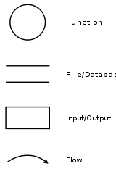

5.1 DFD (Level==0)

0.Library Management
System
Users
Users

jlibrary

5.2 DFD (Level==1)

1.6 Add Member
1.1Add Book
1.7 Delete Member
1.4 Issue Book
1.3 Change Quantity
1.2 Delete Book
1.5 Return Book
1.8 Search Book
1.9 View All Books
1.10 View All Members
borrow
books
member
5.3 E R diagram

Member Name
Fine

Member ID
Books Issued

Member

1

Borrows

NumberOfCopies
Book ID

M
(0, 2)

Shelf No
Books

Book Name

Available

Author
Publisher

6. Software Interface

6.1 Main window:

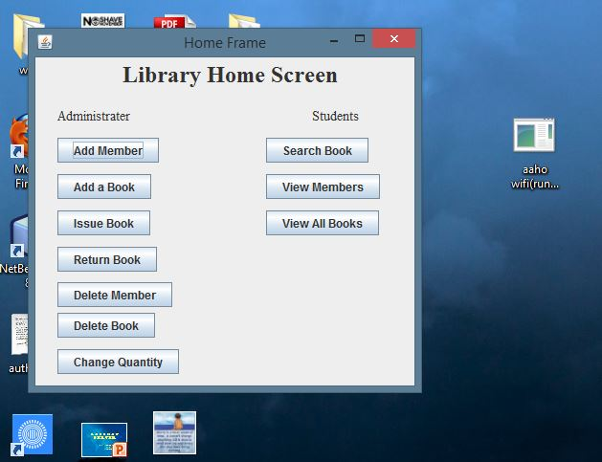

6.2 Add Member:
(Successful added)

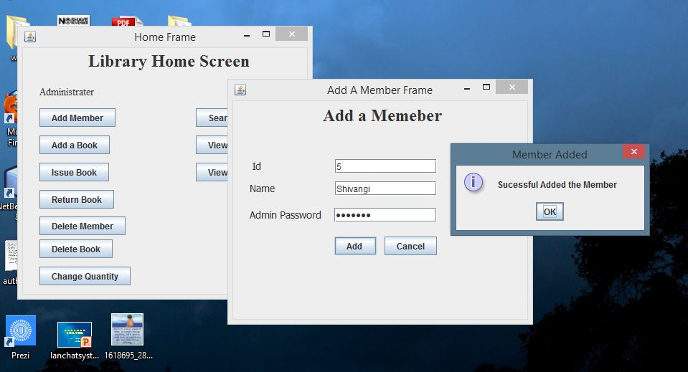

(Unsuccessful):

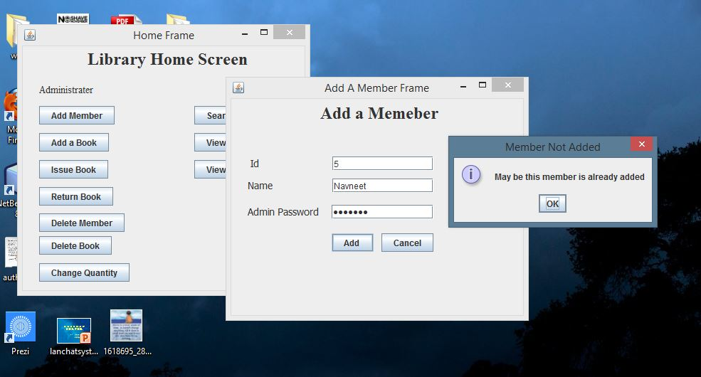

6.3 Add Book:

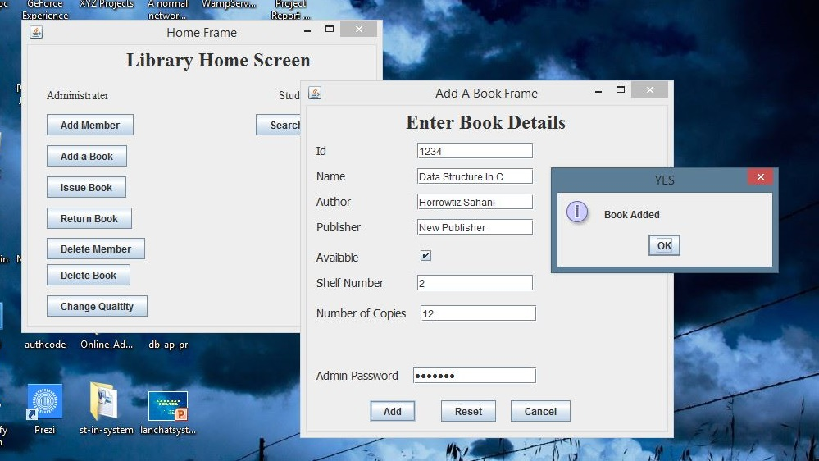

6.4 Change Book Quantity:

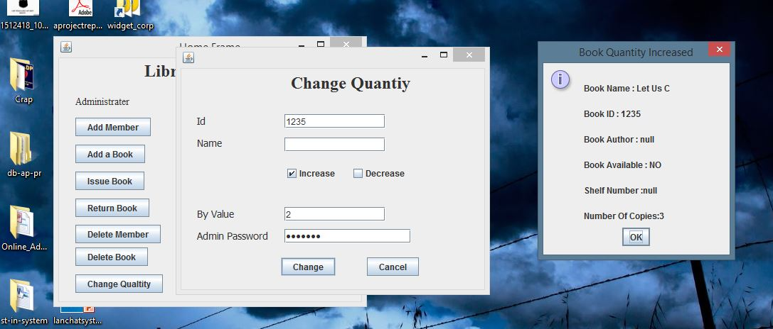

6.5 Issue Book:
(Successful)

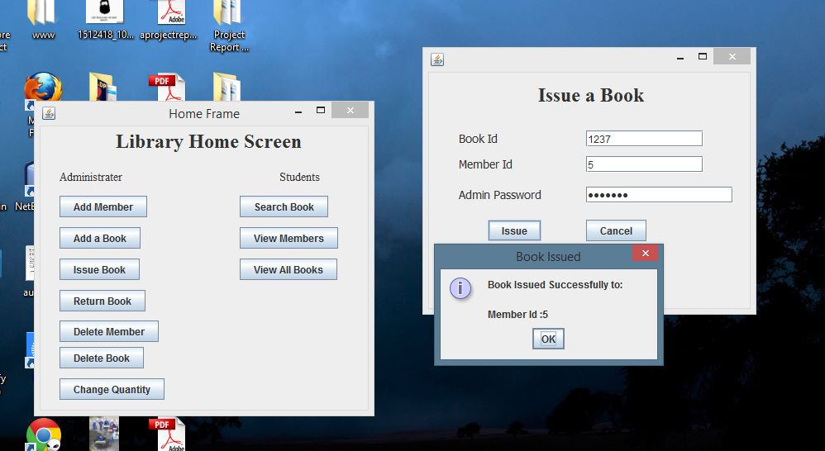

(Unsuccessful):

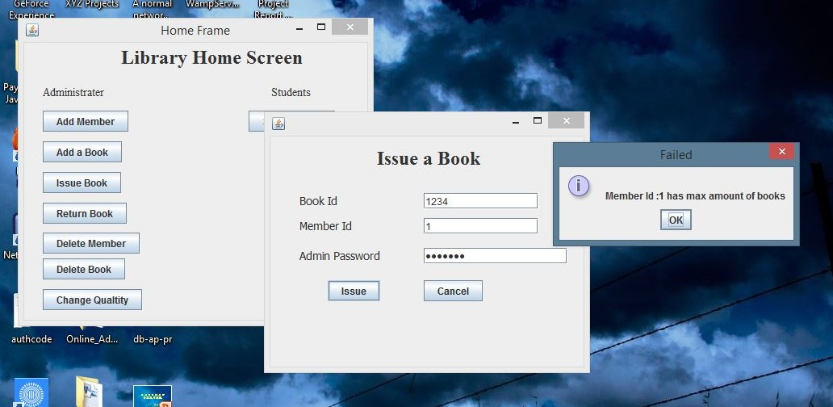

6.6 Return Book:

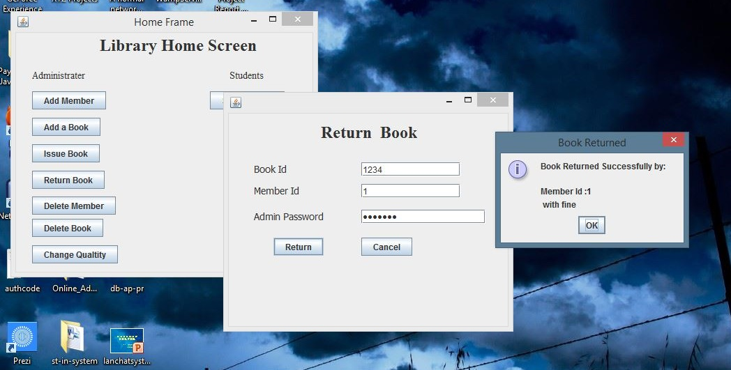

6.7 Delete Member:

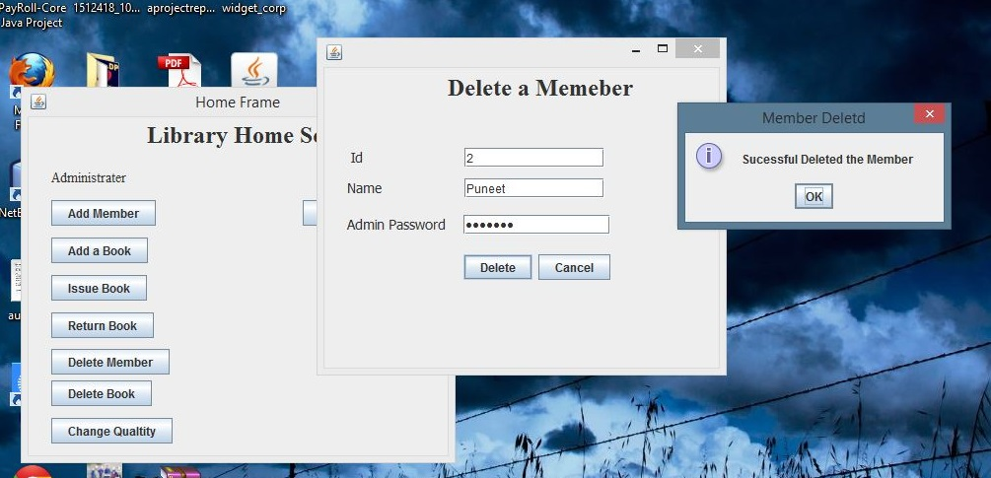

6.8 Delete Book:

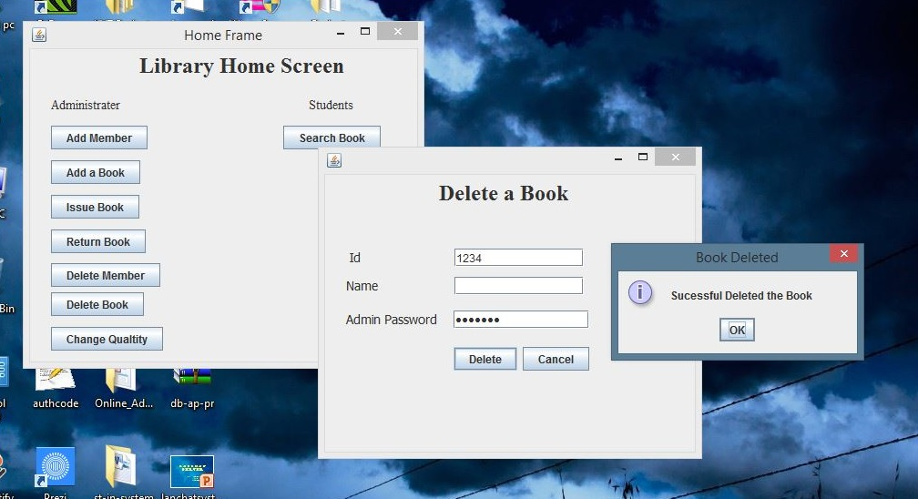

6.9 Search Book:

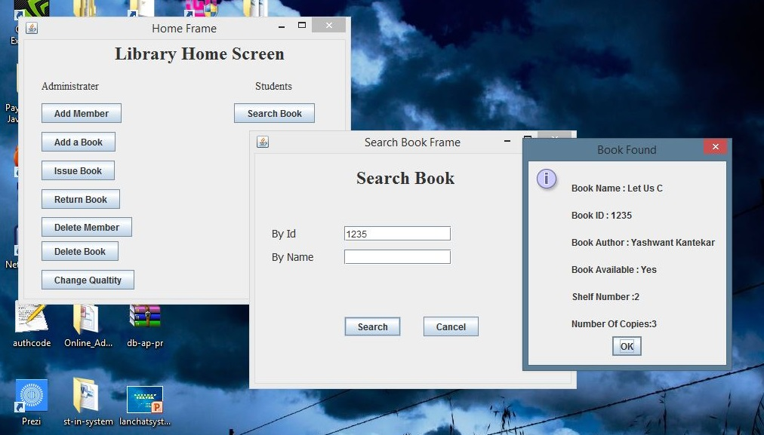

6.10 View All Books:

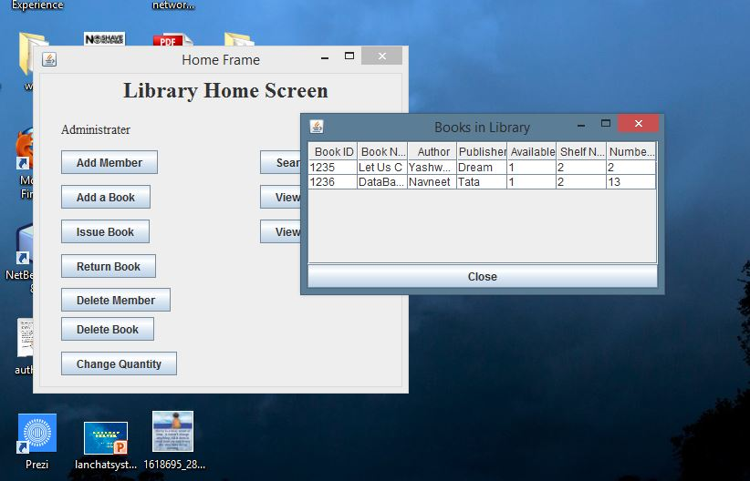

6.11 View All Members:

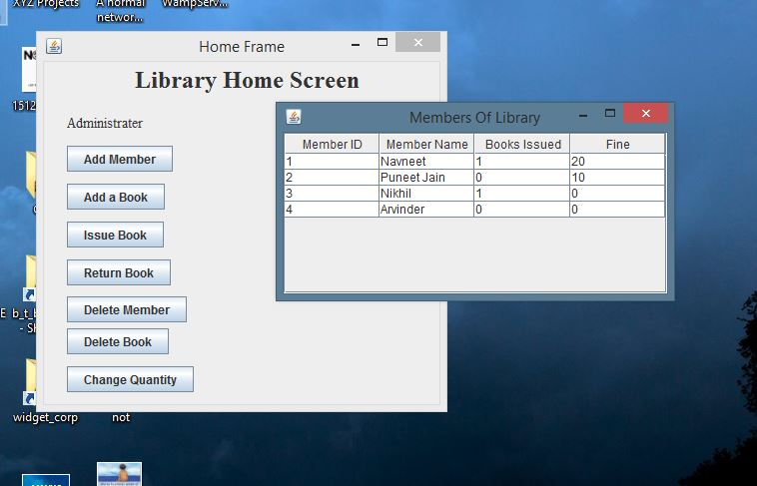
7. Testing

Software Testing is the process of exercising or evaluating a system or system components by manual or automated means to verify that it satisfies specified requirements. It is the process of executing a program or systems with the intent of finding errors.
In software life cycle the earlier the errors are discovered and removed, the lower is the cost of their removal. Software testing is itself an expensive activity, yet launching of software without testing may lead to cost potentially much higher than that of testing. Effective software testing will contribute to the delivery of higher quality software products, more effective users, and lower maintenance costs, more accurate and reliable results. Hence, software testing is necessary and important activity of software development life process.
Test case can be defined as a set of test inputs, execution conditions, and expected results developed for a particular objective, such as to exercise a particular program path or to verify compliance with a specific requirement. During testing, we compare the observed output with expected output to know the outcome of a test case. If expected and observed outputs are different, then, there is a failure and it must be recorded properly on order to identify the cause of failure. If both are same, then, there is no failure and program behaved in the expected manner.
The test case designer’s main objective is to identify good test cases. A good test case has a high probability of finding an error. It should be “best of breed”, not redundant and should be neither too simple nor too complex. The set of test cases is called a test suite.

7.1 Testing Strategies:
- White Box Testing: White Box Testing, also called structural testing is a software testing technique in which we derive test cases from an examination of program’s logic. Unlike black box testing that uses the program specification to examine outputs; white box testing is based on specific knowledge of the source code to define the test cases and to examine outputs.
Using white box testing methods, the software engineer can derive test cases that
- guarantee that all independent paths within a module have been exercised at least once,
- exercise all logical decisions of their true and false sides,
- execute all loops at their boundaries and within their operational bounds,
- exercise internal data structures to ensure their validity.

When we look in to the program, examine the code and watch it as it runs. This activity is dynamic and is about testing a running program, therefore it is called dynamic white box testing. If we want to test the program without running it, meaning thereby examining and reviewing it, then it is called static white box testing.

- Black Box Testing: Black box testing, also called as functional testing, focuses on the functional requirements of the software. That is black box testing enables the software engineer to derive set of input conditions that will fully exercise all functional requirements for a program. It involves only observation of the output for certain input values. There is no attempt to analyze the code, which produces the output. Testing is conducted without knowledge of software implementation i.e. the system is treated as a black box hence it is called as black box testing.
Black box testing attempts to find errors in the following categories
- incorrect or missing functions
- interface errors
- errors in data structures or external data base access
- behavior or performance errors
- initialization and termination errors
Unlike white box testing, which is performed early in the testing process, black box testing tends to be applied during later stages of testing. There are a number of techniques that can be used to design test cases which have been found to be very successful in detecting errors.
- Unit Testing: Unit testing is the process of taking a module and running it in isolation from rest of the software product by using prepared test cases and comparing the actual results with the results predicted by the specification and design of the module. A unit test is the lowest level of testing and is normally done by the developer himself. Unit tests are performed for classes, blocks and service packages. Unit testing is normally considered as an adjunct to the coding step. After source level code has been developed, reviewed and verified for correspondence to component level design, unit test case design begins. Usually white box testing approaches are used for unit testing and the steps can be conducted in parallel for multiple modules.
- Integration Testing: Software integration testing combines or integrates components of the software system and tests the resulting configuration to determine if it works as required and expected. One specific target of integration testing is the interface. Integration testing can be either incremental or non incremental. Incremental testing is performed by testing a small part of the system and then incrementally adding components to the configuration, performing specific tests on each increment. Non incremental testing involves assembling all components of the system and then testing them all at once.
Incremental testing has proven to be a more successful approach. Two main strategies are used to integrate a system incrementally: top-down and bottom-up. Top-down testing is the process of integrating the system under test, progressively, from top to bottom, using simulations of low-level components (called stubs) during testing to complete the system. This is in contrast to bottom-up testing, in which the system under test is built up progressively, from bottom to top, using software drivers to simulate top-level components during testing.
- System Testing: The testing that is conducted on the complete integrated products and solutions to evaluate system compliance with specified requirements on functional and non functional aspects is called as system testing. System testing concerns testing the entire system or the application as such. This takes an end – user view of the system and the test cases perform typical end – user actions. System testing is done after unit and integration testing phases. It involves both functional and non functional testing of the product.
- Functional Testing: Helps in verifying what the system is supposed to do. It aids in testing the product’s features or functionality. It has only two results – requirements met or not met. Functional testing normally depends on the product and not on the environment. It requires in – depth customer, product as well as domain knowledge to develop different test cases and find critical defects. It is performed in all phases of testing i.e. unit, integration and system testing.
- Non-functional Testing: It is performed to verify the quality factors such as reliability, scalability, performance, scalability etc. These quality factors are also called non – functional requirements. It requires a large amount of resources and the results are different for different configurations and resources. It is a very complex method as large amount of data needs to be collected and analyzed. The focus point is to qualify the product. It is not a defect finding exercise.
- Acceptance Testing: It is normally performed by the organization ordering the system and it is the final check by the ordered. This is often also the validation of the system. The system is now tested in its real environment. This type of testing is often called alpha testing. The tests may range from ad hoc tests to well planned systematic series of tests. This test can be done for a longer time when the system is working in the environment for which it has been developed. When the testing has been done, the decision is made as to whether the product is to be accepted or not. If there is no specific ordered, for example in the case of a compiler product, beta testing is often used. This means that the product is tested by specially selected customers who use the system and report the faults they detect. Beta- testing is done before the product is shipped and is form of pre– release.

8. Database design
A database is an organized mechanism that has the capability of storing information through which a user can retrieve stored information in an effective and efficient manner. The data is the purpose of any database and must be protected.
The database design is a two level process. In the first step, user requirements are gathered together and a database is designed which will meet these requirements as clearly as possible. This step is called Information Level Design and it is taken independent of any individual DBMS.
In the second step, this Information level design is transferred into a design for the specific DBMS that will be used to implement the system in question. This step is called Physical Level Design, concerned with the characteristics of the specific DBMS that will be used. A database design runs parallel with the system design.

The organization of the data in the database is aimed to achieve the following two major objectives.
- Data Integrity
- Data independence
Normalization is the process of decomposing the attributes in an application, which results in a set of tables with very simple structure. The purpose of normalization is to make tables as simple as possible.

Normalization is carried out in this system for the following reasons.
- To structure the data so that there is no repetition of data, this helps in saving.
- To permit simple retrieval of data in response to query and report request.
- To simplify the maintenance of the data through updates, insertions, deletions.
- To reduce the need to restructure or reorganize data which new application requirements arise.

8.1 Tables Structure

Table Name: books

Fieldname | Data Type | Length | Key
BookID | Varchar | 40 | Primary
BookName | Varchar | 40
Author | Varchar | 40
Publisher | Varchar | 40
Available | Varchar | 1
ShelfNumber | Varchar | 5
NumberOfCopies | Varchar | 5

Table Name: borrow

Fieldname | Data Type | Length | Key
BookID | Varchar | 40 | Foreign
MemberID | Varchar | 40 | Foreign
IssueDate | Date/Time
ReturnDate | Date/Time

Table Name: member

Fieldname | Data Type | Length | Key
MemberID | Varchar | 4 | Primary
MemberName | Varchar | 20
BookIssued | Varchar | 3
Fine | Integer

9. Future Scope
As the project lacks many feature like good searching of members and books , partial searching , and searching regarding many other fields. The details of the members are also very less. So this project can be extended very easily in the near future to make it more efficient and with more user friendly frames and screens. Icons can be added in this project to look more attractive and very friendly. More modules can be added to make it do more work. More admin id and password can be added so that more Admins can use them and each admin can be provided with different set of authority to change the contents of the database. More functions can be provided to the admin like changing of password and fine to the library members.
10. Bibliography
Books:

- Herbert Schildt (2000) ‘Java Complete Reference’ Tata McGraw Hill
- Ian Somerville ‘Software engineering’
- Rajeev mall ‘Software engineering’
- Elmasri Navathe ‘Fundamentals of database systems’

Online reference:

- www.java.sun.com
- www.youtube.com
- www.lynda.com
- http://www.cs.cf.ac.uk/Dave/HCI/HCI_Handout_CALLER/node167.html

